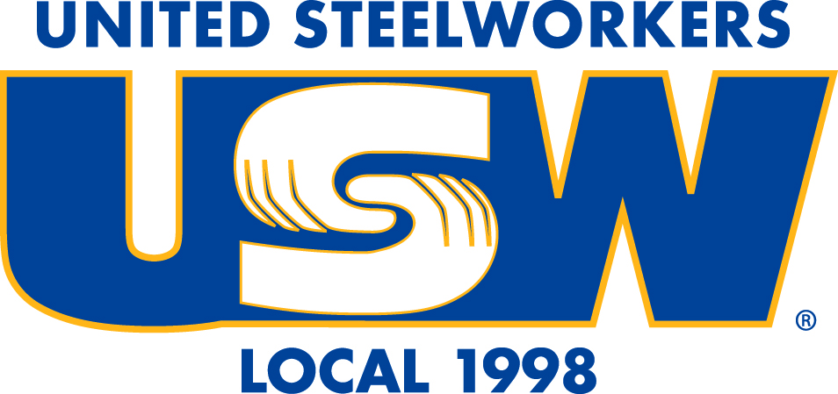
Negotiations Update
USW Local 1998 - Victoria University Unit
January 24, 2022.

Negotiations with the Victoria University administration for a new collective agreement will begin in the near future. After analyzing and discussing their experiences with the collective agreement over the past four years and members’ responses to the negotiating survey, your negotiating team met on December 20 and 21 and January 11 to create a first draft of language (non-monetary) proposals for collective bargaining.

The next step in our preparation for negotiating with the University is to meet with the membership in a series of proposal consultation meetings. We have tried to schedule the meetings at times when people can attend on a lunch break or after their workday is over. The meetings will give members another opportunity to have input into the creation of the negotiating proposals and to hear a general overview of the proposals as they stand now. The inability to have in person meetings indoor causes a significant challenge to this project, but we will do our best to reach as many members as possible. We are holding virtual and outdoor in-person meetings. The schedule is as follows:

Virtual Meetings on Zoom

Tuesday, January 25
12:00 to 2:00 p.m.
6:00 to 7:00 p.m.

Wednesday, January 26
12:00 to 2:00 p.m.
Thursday, January 27
5:00 to 6:00 p.m.

*Note: A Zoom session for members working on the night shift will be scheduled for a day and time yet to be determined.

In Person Meetings on Campus on the east side of Old Vic (subject to change due to weather conditions)

Thursday, January 27
11:00 a.m. to 2:00 p.m.

Saturday, January 29
11:00 a.m. to 2:00 p.m.

Strike Committee

A unified and well-organized membership will be essential for us to win a fair contract. We need to work towards a state of preparedness that will allow us to adapt to new situations and challenges efficiently and with confidence. By being fully prepared for a possible strike or lockout, we will increase our chances of winning a new contract without being forced out on strike or lock out. If we are forced out on strike or lockout, being fully prepared for that worst-case scenario will increase our chances of being back to work in a shorter time than would be the case if we are scrambling to organize ourselves at the last minute.

With those objectives in mind, we have formed a Strike Committee whose job it will be to work with the Negotiating Team in building a strong organizational framework. The Negotiating Team and the Strike Committee will begin meeting soon to start planning a solidarity strategy.

The following members have agreed to serve on the Strike Committee: Mark Austin, Mike Lau, Paul Robinson, Tracy Quan, Alex Thomson, Milly Weidhaas, Jacky Zhang & Candace Zinkweg.

Negotiations Membership Survey Random Draw Winners

The names of all members who completed and submitted a USW negotiations priorities survey were entered into a random draw for one of two Samsung Galaxy Tab S7 FE tablets. The winners of the draw were Devonnia Miller and Jaseetharan Arulappu. Congratulations, Devonnia and Jaseetharan!

In solidarity,
John Ankenman, Chris Greenwood, Wanda Hughes & Mary Lou Scott

**Note: Although the most recent collective agreement expired on June 30, 2021, except for the Early Unreduced Retirement Pension Bridging Benefit and the Letter of Intent – Food Services and Physical Plant Services, its terms and conditions remain in effect.

